WORKPLACE DISABILITY INCLUSION GRANT SCHEME (WDIGS) GRANT APPLICATION PACKAGE | DOCUMENT 5: WORKPLAN TEMPLATE

Australia-Papua New Guinea Economic Partnership (APEP) EmployAbility Project

WDIGS Workplan Template prepared for APEP by Square Circle
24 October 2025
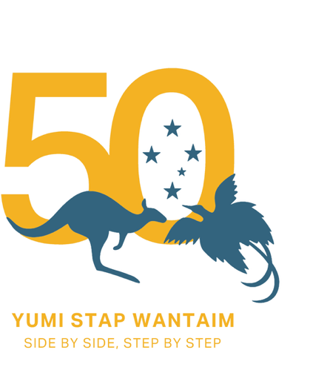

WORKPLAN TEMPLATE

Directions: List the type of activities involved in your project in the first column and provide a brief description in the second column.

It is a requirement that a WORKPLAN TEMPLATE (this document) is completed and submitted with your GRANT APPLICATION FORM (DOCUMENT 3) and your PROJECT COSTINGS TEMPLATE (DOCUMENT 4).
Project activity | Brief description of activity | Time period

